Match each number from the maze to the block code you think will let you complete that step of the maze.

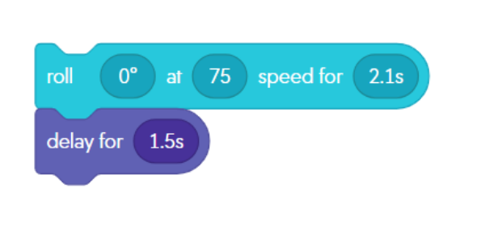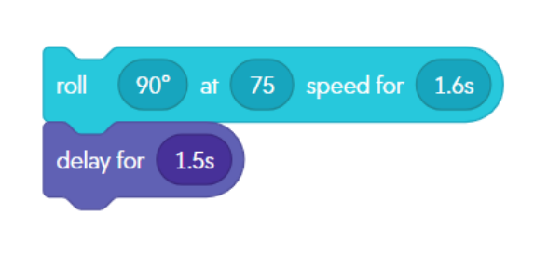

Maze Intro Section

______________________________

______________________________

Match each number from the maze to the block code you think will let you complete that step of the maze. Some are used more than once!

____________________

____________________

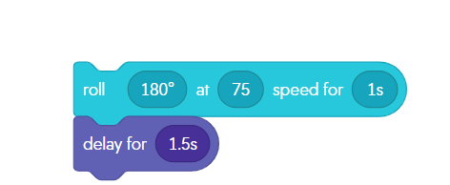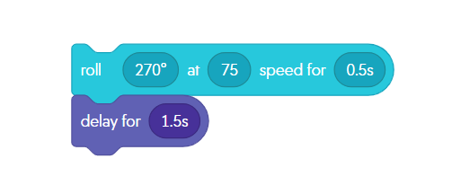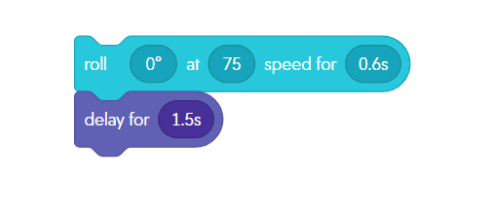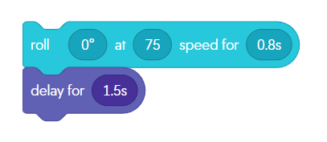

____________________

____________________

____________________

____________________

2

1

Finish

Stop

Start

Wrong Way!!

Wrong Way!!

11

10

9

8

6

7

5

4

3

2

1

Finish

Stop

Stop

Stop

Stop

Stop

Stop

Stop

Stop

Stop

Stop

Start